**Model Development Phase**

| Date | 17th June 2025 |
| --- | --- |
| Team ID | SWTID1749820017 |
| Project Name | Dog Breed Identification using Transfer Learning |
| Maximum Marks | 10 Marks |

**Initial Model Training Code**

The model training code is shown below. It includes model construction, compilation and training using the NASNetLarge architecture and Keras’ ImageDataGenerator. Here we are training two models

1. NASNetLarge model that has a Flatten() layer at the second last layer (model1)
2. NASNetLarge model that has a GlobalAveragePooling2D() layer at the second last layer instead of a Flatten() layer at the end (model2)

NASNetLarge model with Flatten() layer (model1)

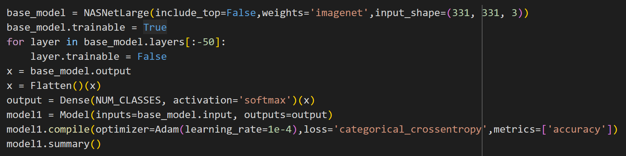

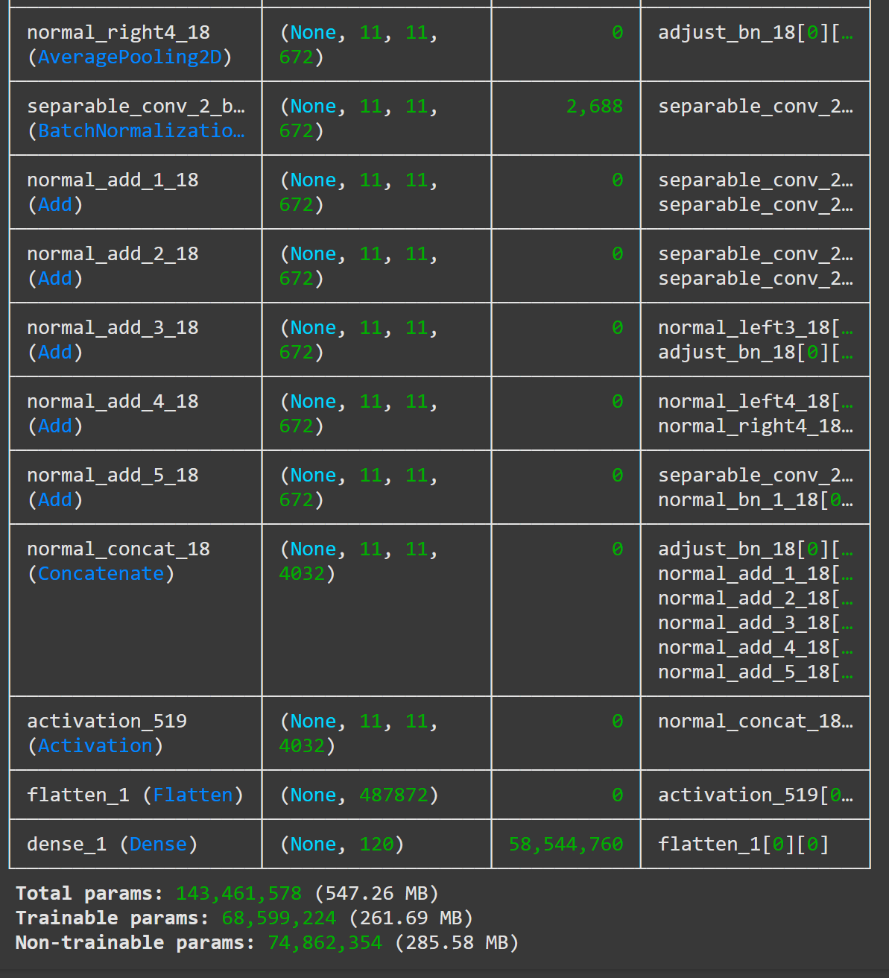

NASNetLarge model with GlobalAveragePooling2D() layer (model1)

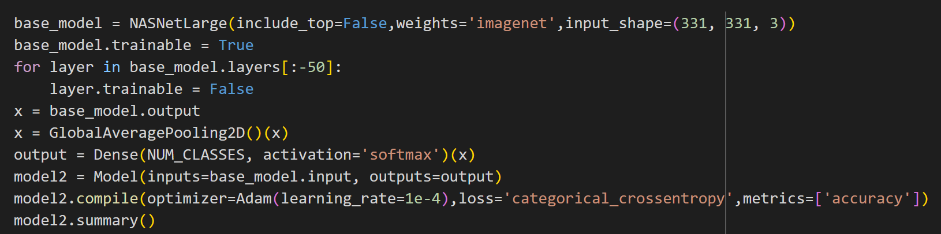

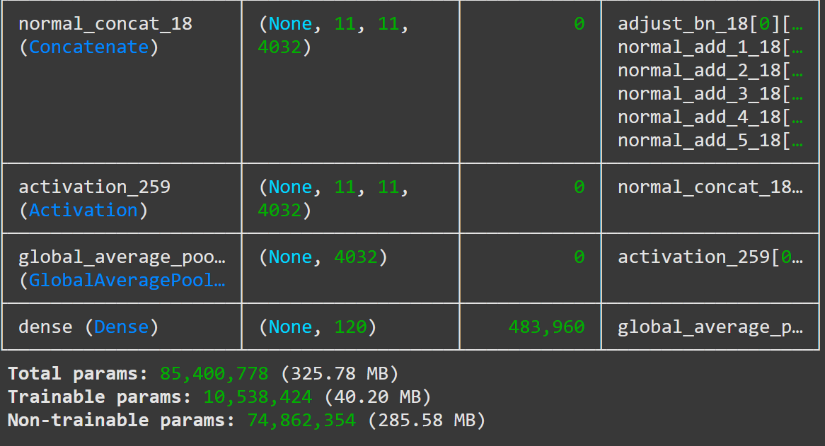

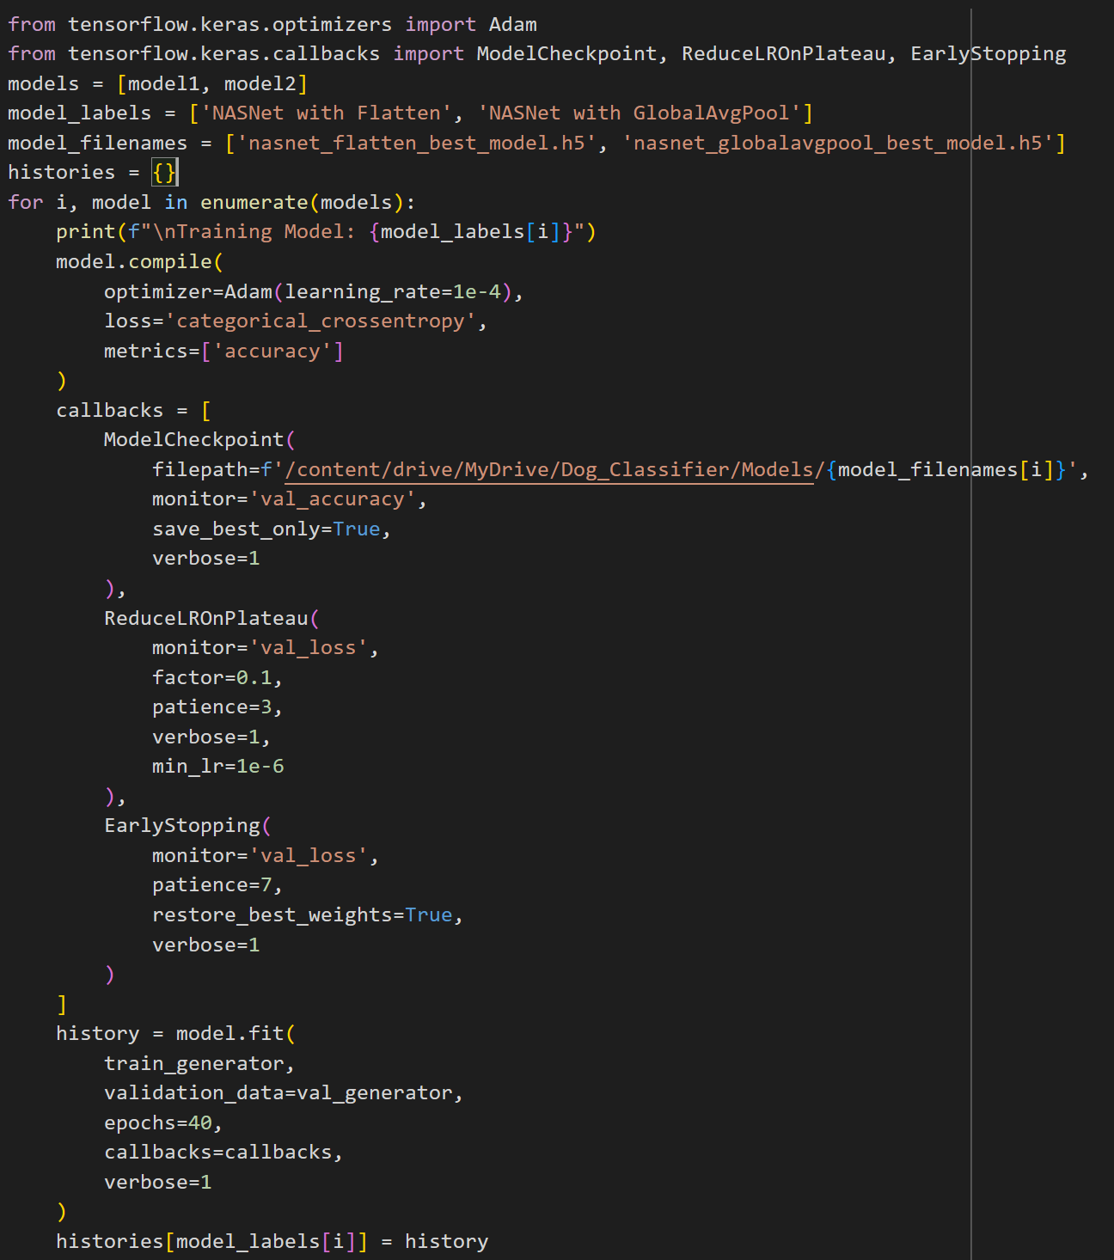

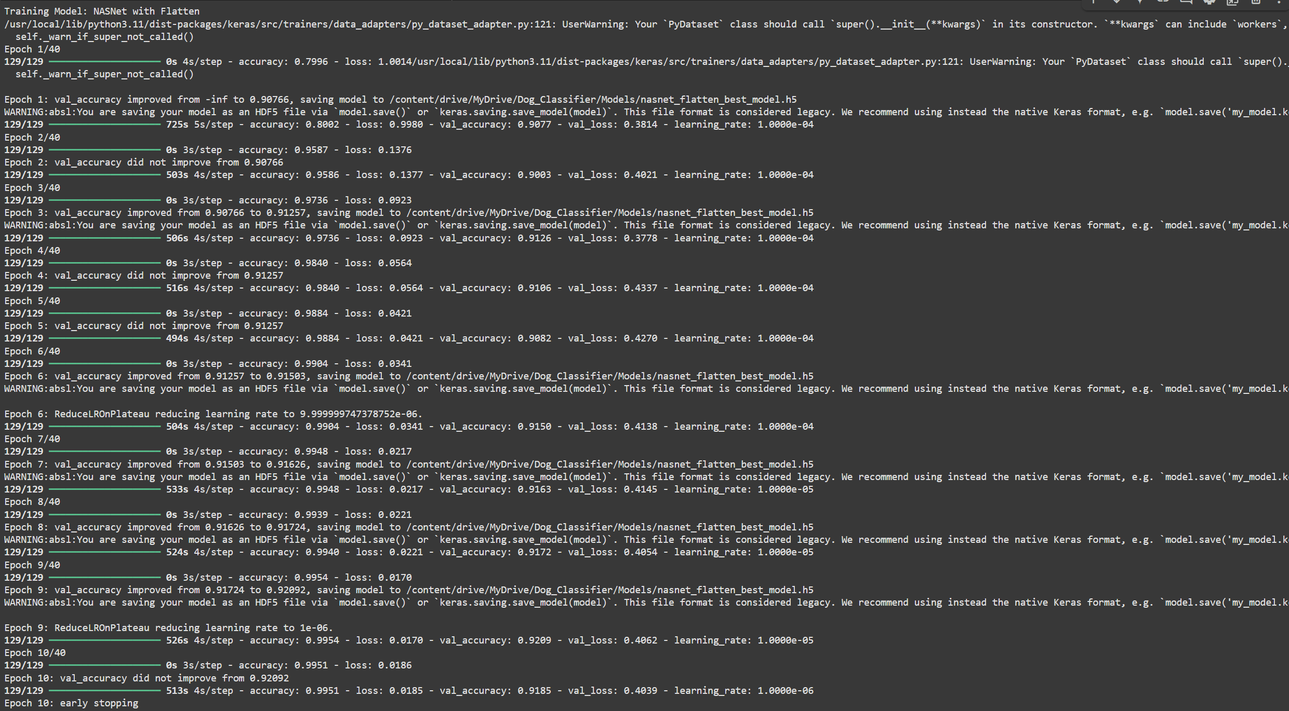

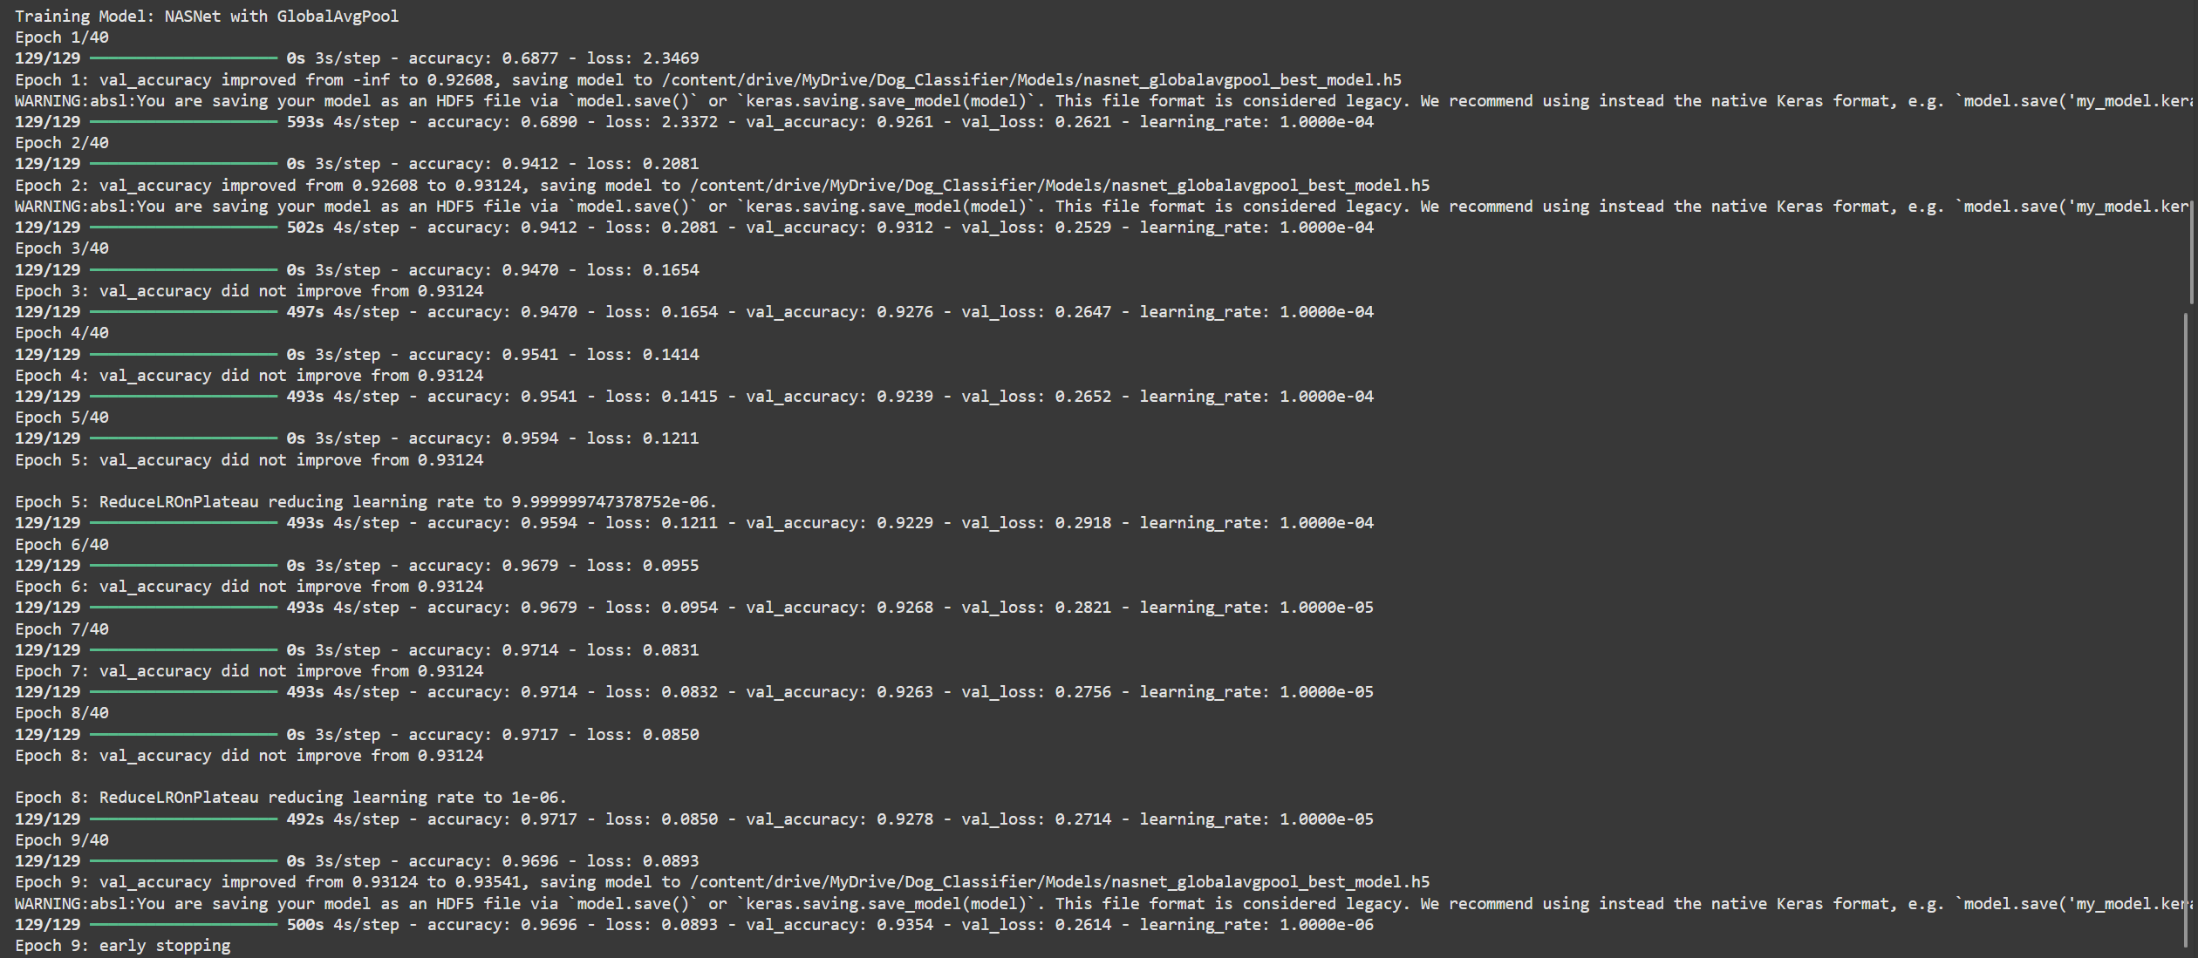

**Model valuation and evaluation report**

|  |  |  |  |
| --- | --- | --- | --- |
| **Model** | **Summary** | **Training and validation performance metrics** | |
| Model 1: NASNetLarge with Flatten() layer | Note: As NASNetLarge has several layers it is not possible to take a screenshot of the entire model summary. So a screenshot of the last 4 layers have been displayed here. To get the full model summary please visit the training_notebook folder in the following github repository:  https://github.com/HCN-22BCT0209/flask-dog-classifier | | Note: As the screenshot of all the epochs is too large to fit here we have attached the screenshot of the last 3 epochs. To view the full training history checkout the training_notebook folder in the following github repository:  https://github.com/HCN-22BCT0209/flask-dog-classifier |
| Model 2: NASNetLarge with GlobalAvgPool() layer | Note: As NASNetLarge has several layers it is not possible to take a screenshot of the entire model summary. So a screenshot of the last 4 layers have been displayed here. To get the full model summary please visit the training_notebook folder in the following github repository:  https://github.com/HCN-22BCT0209/flask-dog-classifier | Note: As the screenshot of all the epochs is too large to fit here we have attached the screenshot of the last 3 epochs. To view the full training history checkout the training_notebook folder in the following github repository:  https://github.com/HCN-22BCT0209/flask-dog-classifier | |

**Accuracy and Loss graphs:**

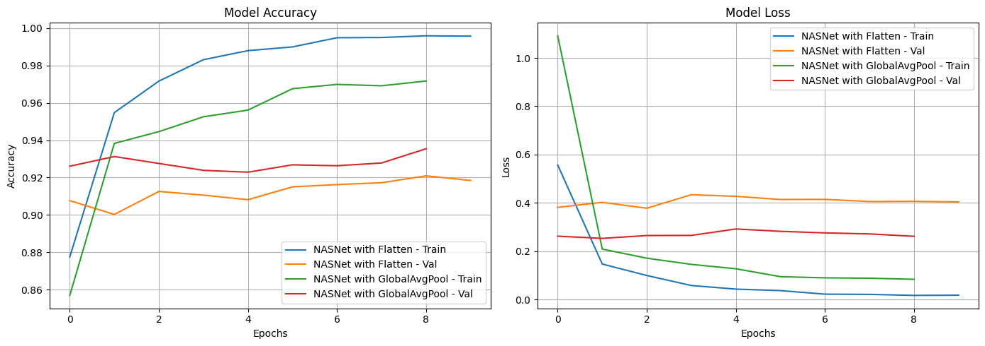

**Confusion Matrix of Model 1 and Model 2:**

